**PAS**

**To:** Dr. Matt Bohm

**From:** PAS

**Project:** Plasma Arc Speaker

**Subject:** Concept Variant 6

**Date:** March 4, 2011

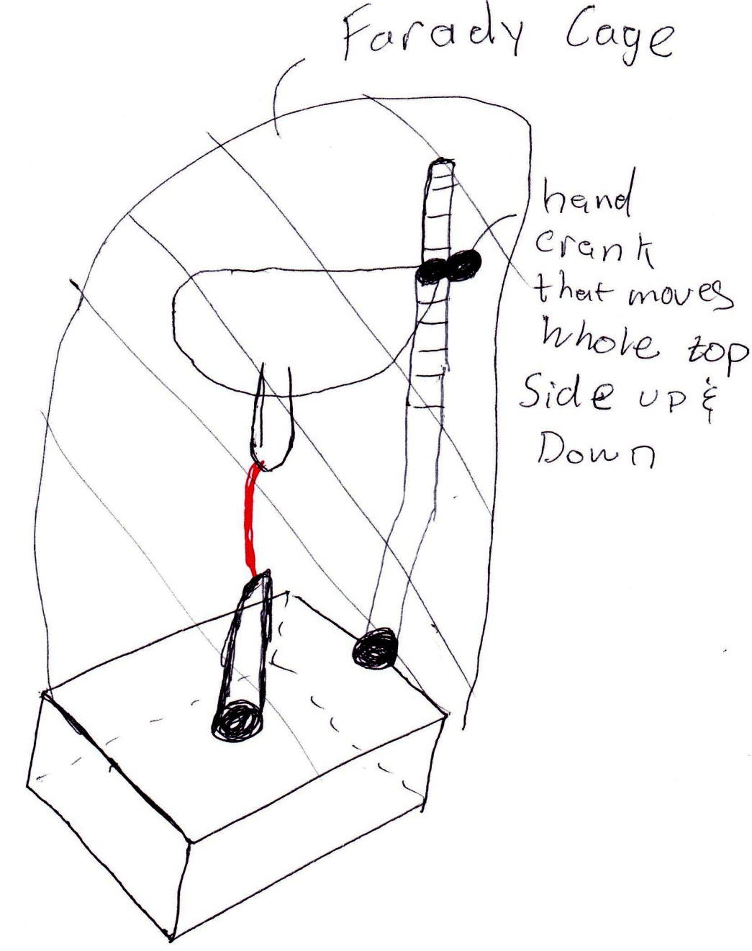

CV 6 has an electrical component housing on the bottom and a single support column.  The column will have teeth and will be adjustable.  The electrode mount will connect to the column with a gear and connection wrapping around the column.  The gear connection and column will act as a manual rack and pinion that will be operated by turning a knob.  This concept makes the adjustment a manual system which allows for more control.